SENIOR SIX SUB MATH LESSON NOTES TERM 3 2026
Integration (A-level) 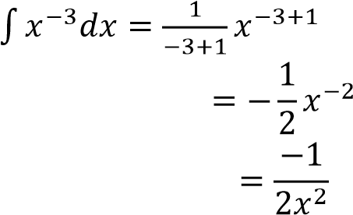
It the reverse of differentiation; thus the topic should be done after studying differentiation.
be considered.  (a) Polynomial functions; |  | Example 2  Evaluate
During integration the following concepts should
term by the new power  According to NCDC, n ≥ 0 | Solution
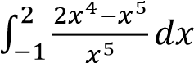
(a)
i.e. increase the power by 1 and divide the
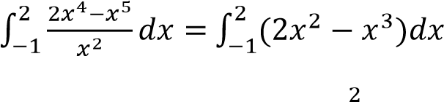
Example 1
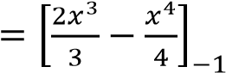

- 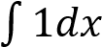
Solution 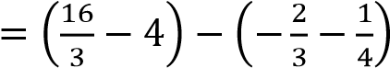
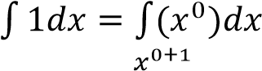

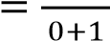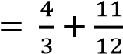
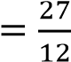
- 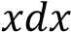
Solution 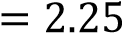
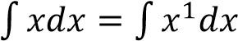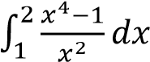
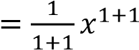 ( b )
+ c
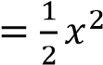 Solution
- 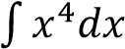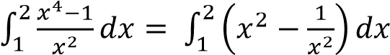
Solution
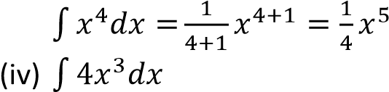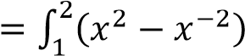
Solution 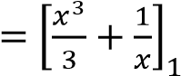
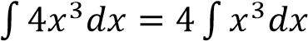
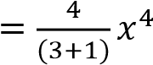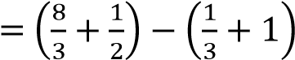
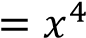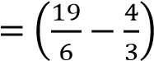
(v) 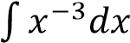
Solution 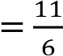

Revision exercise 1
(Answers are given in square brackets)
- Find 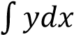 for each of the following
  - y = x³(2 – x²)
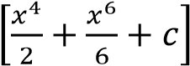
  - y = (x+3)(x+5)
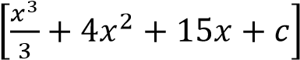
  - y = (x – 3)²
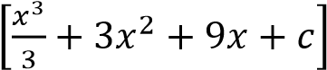

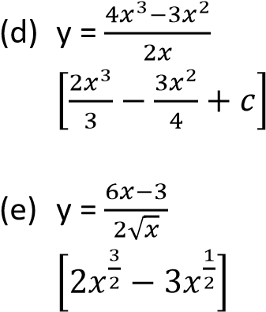

- Evaluate
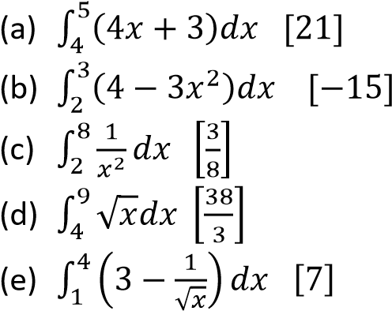
Application of integration
A. Area under a curve
When finding the area under the curve, it is advisable to make a sketch the curve first to visualize the required area.

Area between the curve and x-axis

Example 3
Find the area enclosed by the curves
(a) y = x(x – 4) and x – axis
Solution
When x = 0, y = 0
When x = 4, y = 0
Hence intercepts are (0, 0) and (4, 0)
Turning points when 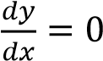
⇨ 2x – 4 = 0 x = 2
when x = 2, y = -4
Nature of turning point
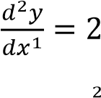
Since 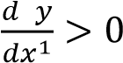, the point (2, -4) is minimum
Sketch
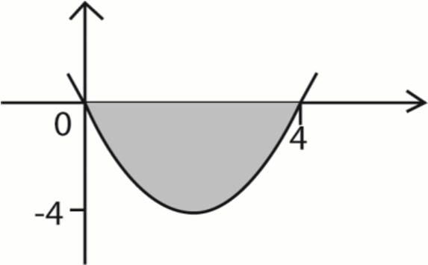
Area required 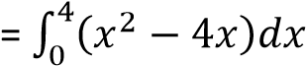
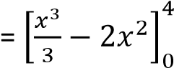
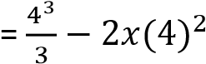
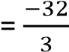
Hence the area under the curve is 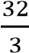
Revision exercise 2
(Answers are given in square brackets)
- Find the areas enclosed by the curves and x-axis
  - y = x² – 4 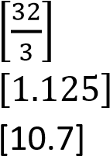
  - y = 2x² – 5x +6
  - y = x² – 2x – 3
- Find the area enclosed by the curve y = x² – 4, the x-axis and line x = 3 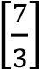
- Find the area encloses between the curve y =x² – 6x + 13, the x-axis, the line x = 3 and the line x = 5

TOPIC 2/2: Random Variables
Competency: The learner analyses concepts of random variables to model real-world situations in various contexts for informed decision making.
Discrete probability distribution
A probability density function (p.d.f) if it takes on specific values
Properties of discrete probability density functions
- P(X=x)0
- The expected value of x is given by E(X) = 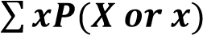=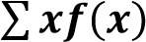
- Var(X) = E(X²) - [E(x)]² where E(X²) =
- Standard deviation =

Examples 1
A discrete random variable has a probability distribution
y | -3 | -2 | -1 | 0 | 1
P(Y=y) | 0.1 | 0.25 | 0.3 | 0.15 | a
Find
(a) value of a
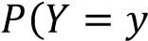)
0.1 + 0.25 + 0.3 + 0.15 + a = 1; a + 0.8 = 1
a = 0.2
  - mode
Mode is the value y with the highest probability, mode = -1
  - P(-3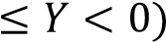
P(-3 = P(Y= -3) + P(Y = -2) + P(Y = -1)
= 0.1 + 0.25 + 0.3
= 0.65
  - P(Y>-1)
P(Y> -1) = P(Y = 0) + P(Y = 1)
= 0.15 + 0.2
= 0.35
  - P(-1<Y<1)
P(-1<Y<1) = P(Y = 0)
= 0.15

Example 2
A discrete random variable X has a probability distribution
X | 1 | 2 | 3 | 4 | 5
P(X = x) | 0.15 | 0.20 | 0.15 | c | 0.1
Find
(i) the value of c
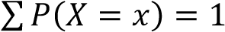
0.15 + 0.20 + 0.15 + c + 0.1 = 1 c +0.6 = 1 c = 0.4

  - mode
The mode is a value with highest probability = 4
  - P(X<4)
P(X<4) = P(X=1) + P(X= 2) + P(X = 3)
= 0.15 + 0.20 + 0.15
= 0.5
  - P(X4
P(X<4) = P(X=1) + P(X= 2) + P(X = 3) + P(X= 4)
= 0.15 + 0.20 + 0.15 + 0.4
= 0.9
  - P(2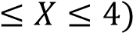
P(2 = P(X = 2) + P(X = 3) + P(X = 4)
= 0.20 + 0.15 + 0.4
= 0.75
  - P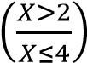
P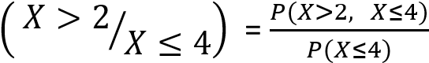
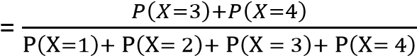
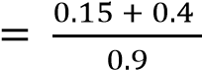
= 0.6111

Example 3
The table below shows the probability distribution of the number of Compact Discs (CDs) sold.
Number of CDs (x) | 0 | 1 | 2 | 3 | 4
Probability, P(X = x) | 0.05 | 0.28 | c | 0.22 | 0.09
Determine the:
- Value of c (03 marks)
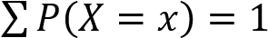
⇨ 0.05 + 0.28 + c + 0.22+ 0,09 = 1 c =0.36
- Probability that at least 2 CD’s are sold. (03 marks) P(x ≥2) = P(x =2) + P(x = 3) + P(x = 4)
= 0.36 + 0.22 + 0.09
= 0.67
- Expectation, E(X) (03 marks) E(X) = ∑xP(X= x)
= 0.05 x 0 + 0.28 x 1 + 0.36 x 2 + 0.22 x 3 + 0.09 x 4 = 2.02
- Standard deviation. (06marks) Var(X) =E(X²) = ∑x²P(X= x)
= 0.05 x 0² + 0.28 x 1² + 0.36 x 2² + 0.22 x 3² + 0.09 x 4²
=5.14
S.D =

Example 4
A discrete random variable W has a probability distribution shown below
w | -3 | -2 | -1 | 0 | 1
P(W =w) | 0.1 | 0.25 | 0.3 | 0.15 | d
Find
- The value of d (02 marks)
Solution
Total probability = 1 = 0.1 + 0.25 + 0.3 + 0.15 + d d + 0.8 = 1 d = 0.2
- P(-3 ≤ W ≤ -1) (03marks)
P(-3 ≤ W ≤ -1) = P(W = -3) + P (W = -3) + P(W = -1)
= 0.1 + 0.25 + 0.3 = 0.65 (c) P(W > -1) (02 marks)
P(W > -1) = P(W = 0) + P(W = 1) = 0.15+ 0.2
= 0.35
(d) (i) the mode (01 mark)
-1
  - the mean (01mark)
  - the variance of the distribution (05marks)
w | -3 | -2 | -1 | 0 | 1
w² | 9 | 4 | 1 | 0 | 1
P(W =w) | 0.1 | 0.25 | 0.3 | 0.15 | 0.2
w. P(W =w) | -0.3 | -0.5 | -0.3 | 0 | 0.2
w². P(W =w) | 0.9 | 1.0 | 0.3 | 0 | 0.2
Mean E(W) = ∑ ( ) = -0.3 – 0.5 – 0.3+ 0.2 = -0.9
Var(W) =
= 0.9 + 0.1 + 0.3 + 0.2 – (-0.9)2
= 1.5 – 0.81
= 0.69

Example 5
A random variable X has a probability distribution given by
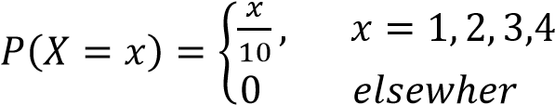
Calculate:
- P(1 ≤ X < 3). (03marks
P(1 ≤ X < 3) = P(X=1) + P(X = 2) = 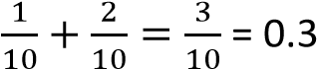
- the mean of X, E(X) (02 marks)
X | 1 | 2 | 3 | 4
X =x | 0.1 | 0.2 | 0.3 | 0.4
x(P(X=x) | 0.1 | 0.4 | 0.9 | 1.6
E(X) = 0.1 + 0.4 + 0.9 + 1.6 = 3

Example 6
A discrete random variable has a probability function 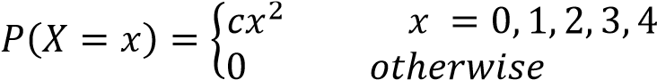
Find the value of c and draw the graph of P(X = x)
Solution
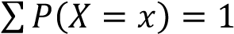
c(0²) + c(1²) + c(2²) + c(3²) + c(4²) = 1 c + 4c + 9c + 16c = 2
c = 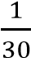

X | 0 | 1 | 2 | 3 | 4
P(X =x) | 0 | 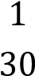 | 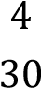 | 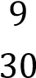 | 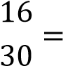
Graph
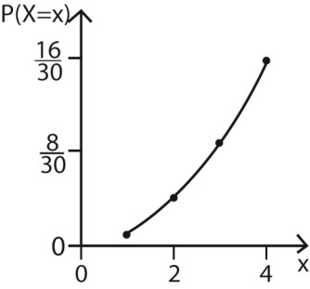

Example 7
A discrete random variable has probability function
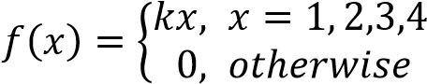 , find the value of k and draw the graph of f(x)
Solution
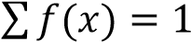
k + 2k + 3k + 4k = 1
k = 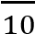
X | 0 | 1 | 2 | 3 | 4
P(X =x) | 0 | 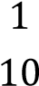 | 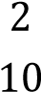 | 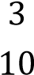 | 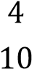
Graph
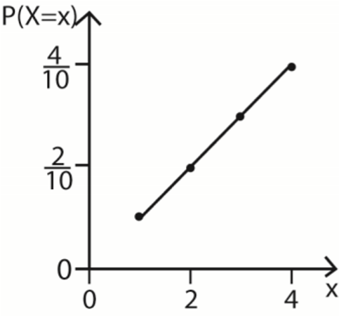

Example 8
A random variable X of a discrete probability distribution given by
P(X=1) = 0.2, P(X=2) = P(X=3) = 0.1, P(X=4) = P(X=5) = c
Find the value of the constant c and draw the graph of P(X = x)
Solution
0.2 + 0.1 + 0.1 + c + c = 2; c = 0.3

Example 9
A discrete random variable has a probability function
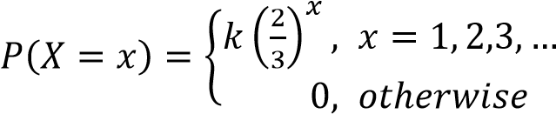
Find the value of k
Solution
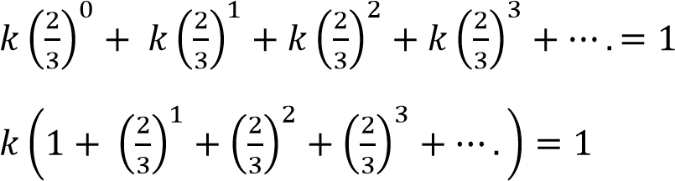
Sum to infinity = 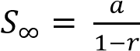
⇨ 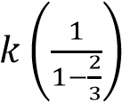= 1; k =

Example 10
A discrete random variable X has a probability function
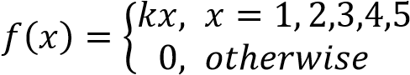
Find
(i) the value of k
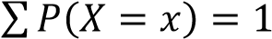
k + 2k + 3k + 4k + 5k = 1
15k = 1 k = 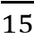
(ii) | P(X = 3)
P(X=3) = 3k = 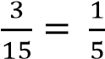
- P(X3)
P(X3) = P(X=3) + P(X=4) + P(X = 5)
= 3k + 4k + 5k
= 12k
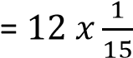
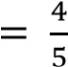
- P(X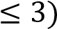
P(X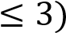= P(X= 1) + P(X=2) + P(X = 3)
= k + 2k + 3k
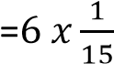
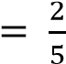
- (v) P(1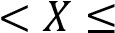3)
P(1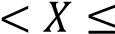3) = P(X=2) + P(X = 3)
= 2k + 3k
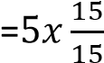
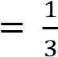
- P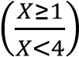

P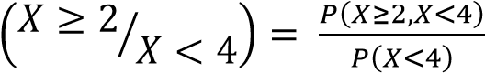
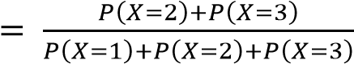
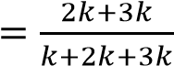
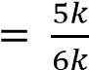
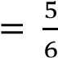

Example 11
A discrete random variable X can take on values 0, 1, 2, and 3 only. If E(X) = 1.4, P(X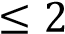) = 0.9 and
P(X1) = 0.5. Find (i) P(X=1) (ii) P(X =0)
Let P(X = 0) = a, P(X=1)=b, P(X=2)= c p(X = 3) = d
- + b + c + d = 1 ……………. (i) P(X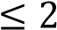) = a + b+ c = 0.9 … (ii) Eqn. (i) and eqn. (ii) d = 0.1
P(X1) = a + b = 0.5 ……. (iii)
Eqn. (i) and eqn. (iii) 0.5 + c + 0.1 = 1 c = 0.4
E(X) = 0 x a + 1 x b + 2 x c + 3 x 0.1 = 1.4
= b + 2c + 0.3 = 1.4
- + 2c = 1.1 b + 2 x 0.4 = 1.1 b = 0.3
a = 0.5 – 0.3 = 0.2
Hence, (i) P(X=1) = 0.3 (ii) P(X =0) = 0.2

Revision exercise 1
(Answers are given in the square brackets, [ ], at end of each question)
- The discrete random variable Y has a probability distribution is given by
P(Y=y) = cy, y = 1, 2, 3, 4
Find (i) value of c = 0.1 (ii) E(X) =
- A discrete random variable has p.d.f
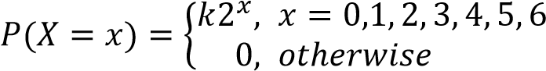 ,
Find
    - (i) value of k 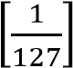 ,
    - Mean [5.01]

- A discrete random variable X has a probability distribution
x | 0 | 1 | 2 | 3 | 4 | 5
P(X= x) | 0.11 | 0.17 | 0.2 | 0.13 | p | 0.09
Find
      - the value of p [0.3]
      - Expected value of X [2.61]
- A random variable X of discrete probability distribution is given by
x |  | -1 |  | 0 |  | 1 |  | 2
P(X= x) |  | 0.25 |  | 0.10 |  | 0.45 |  | 0.20
Find
- P(-1 X <1) [0.35]
- E(X) = [0.6]
5. A discrete random variable X has a probability distribution
x | 1 |  | 2 |  | 3 |  | 4 |  | 5
P(X = x) | 0.2 |  | 0.25 |  | 0.4 |  | 0.1 |  | 0.05
Find
  - Mean [2.55]
  - The variance (1.148]
  - Standard deviation = [1.0714]

- A random variable X of a discrete probability distribution given by
x | 10 | 20 | 30
P(X = x) | 0.2 | 0.3 | 0.5
Find
  - E(X) [22]
  - Var (X) [36]
  - Standard deviation[6]
x | 1 | 2 | 3
P(X = x) | 0.2 | 0.3 | 0.5
- A random variable X of discrete probability distribution is given by

Find (i) E(X) = 2.3 (ii) E(X²) = 5.9 (iii) Var (X) = 0.61
- A random variable X of discrete probability distribution is given by

x | -1 | 0 | 1 | 2
P(X = x) | 0.25 | 0.1 | 0.45 | 0.2
Find: (i) P(-1≤ X < 2) = 0.8 (ii) E(X) = 0.6 (iii) E(2x + 3) = 4.2
- A random variable X of a discrete probability distribution
P(X = 0) = 0.05, P(X = 1) = 0.45 P(X = 2) = 0.5
Find: (i) E(X) = 1.45, (i) E(X²) = 2.45 (iii) Var (X) = 0.348
- A random variable X of discrete probability distribution is given by P(X = 1)
0.1, P(X= 2) = 0.2, P(X = 3) = 0.3, P(X =4)= 0.4
Find (i) E(X) = 3 (ii) Var (X) = 1 (iii) P(X = 2/X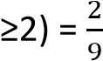
- The discrete random variable Y has a probability distribution P(Y = y) = k =1, 2, 3, 4, 5,6
Find (i) mean, μ = 3.5 (ii) E(3X +4) = 15(iii) E(X²)=14.5 (iv) standard deviation = 1.708
- The discrete random variable R has a probability distribution is given by
P(R = r) = 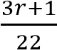; r = 0, 1, 2, 3
Find (i) mean, 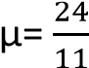, E(R2) = 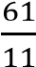(iii) E(3R-2) = 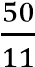
- The discrete random variable R has a probability distribution given by
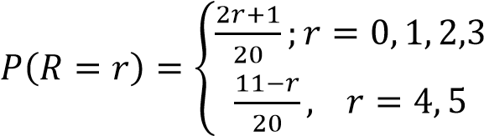
Find (i) E(R) = 2.55, (ii) Var(R) = 1.45
- The discrete random variable X has a probability distribution given by
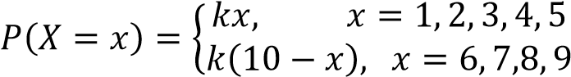
Find (i) constant, k = 0.04, (i) E(X) = 5 (iii) Var(X) = 4
- The discrete random variable X has a probability distribution is given by
P(X =x) = kx, x = 1, 2, 3,…..n ; where k is a constant
Show that k = 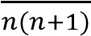, hence find in terms of n the mean X = 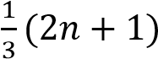
- A random variable X of a discrete probability distribution given by
P(X = 0) = P(X=1) = 0.1, P(X = 2) = 0.2, P(X= 3) = P(X = 4) = 0.3. Find Var (X) = 1.64
- A random variable X of a discrete probability distribution given by
P(X = 2) = 0.1; P(X= 4) = 0.3; P(X = 6) = 0.5; P(X = 8) = 0.1. Find Var (X) 2.56

Continuous random variable
A probability density function (p.d.f) is continuous if it takes on values between intervals.
Properties of a continuous probability density functions
- f (x) ≥ 0
- 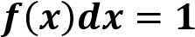
- E(X)= 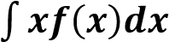
- E(X²)= 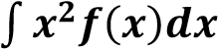
- Var(X) = E(X²) - [E(x)]²
- Standard deviation =

Example 12
A continuous random variable X has a probability density function given by,
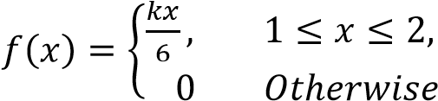
Where k is a constant
- Find
- The value of k (04marks)
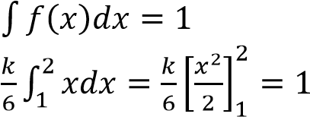
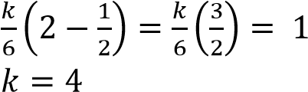

- P(X ≥ 1.5) (04marks)
P(X 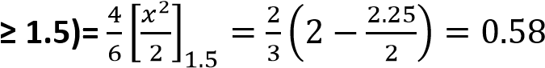
- The mean of X, E(X) (03 marks)
E(X) =
- Sketch the graph of f(x) (04 marks) f(x) = 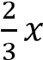
At x = 1, fx =
At x = 2, fx =



fx

2

1

Example 12
A random variable X has a probability density function, f(x), defined by
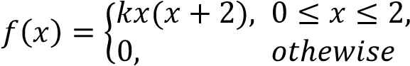
where k is constant
Determine
- value of k (04marks)
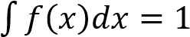
⇨ 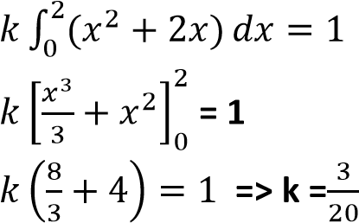

- P(1≤ X ≤1.5) (03marks)
P(1
- Expectation, E(X) (04marks)
E(X) = 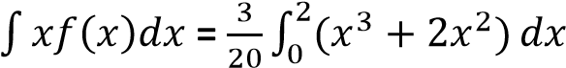
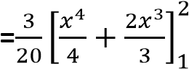
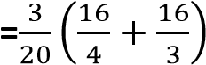
= 1.4 (d) Variance, Var(X) (04marks)
E(X²) = 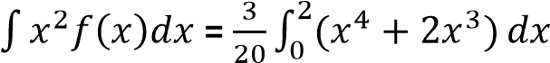
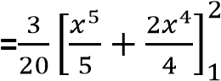
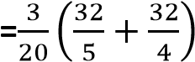
= 2.16
Var(X) = E(X²) – (E(x))²
= 2.16 – (1.4)² = 0.2

Example 14
A cumulative random variable X, has a probability density function (pdf) given by
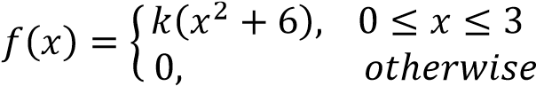
Where k is a constant Determine the:
- value of k (04 marks)
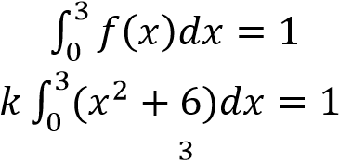
k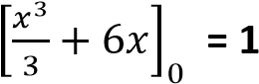
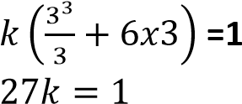
k = 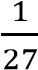
- P(X> 1). (04 marks)
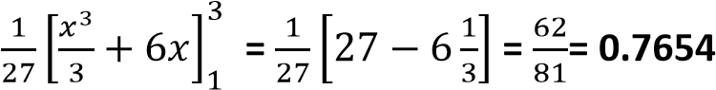
- expectation, E(X) (03marks)
E(X) 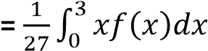
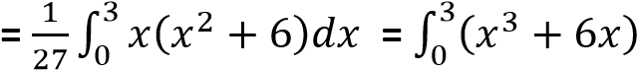
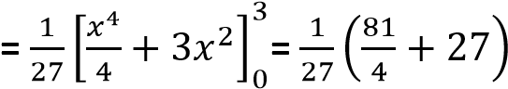
= 1.75
(iv) variance, Var (X)(04marks)
E(X²)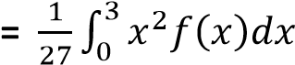
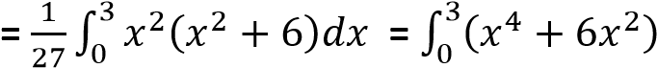
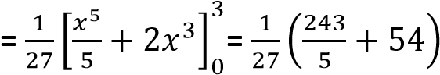
= 3.8
Var(X) = E(X²) – (E(x))²
= 3.8 – (1.75)²
= 0.7375

Example 15
A random variable of continuous p.d.f is given by 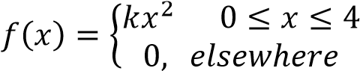
Find (i) value of k and sketch f(x) (ii) P(1 ≤ x ≤ 3)
Solution



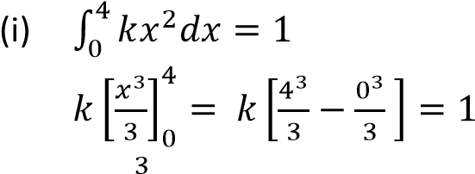
Sketch

⁄

f(x)

0
4 x

k = 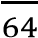
When x = 0, f(x) = 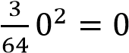
When x = 4, f(x) = 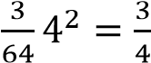
(ii) P(1 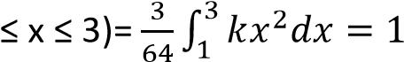
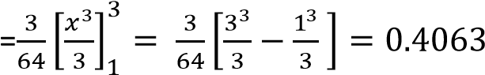

Example 16
A random variable X of a continuous p.d.f is given by 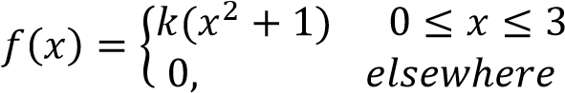
Find
- value of k and sketch f(x)
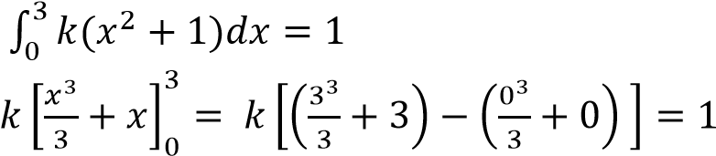
k = 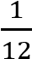
When x = 0, f(x) = 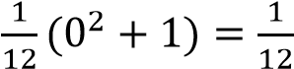
When x = 3, f(x) = 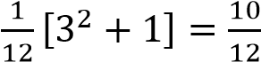
- P(1 ≤ x ≤ 3)




0
3 x

⁄

f(x)

Example 17
A random variable X of continuous p.d.f is given by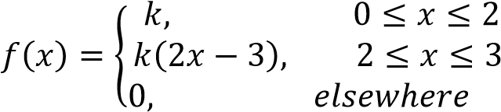
Find (i) value of k and sketch f(x) (ii) P(X<1) (ii) P(X > 2.5) (iv) 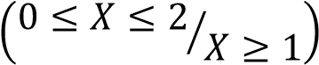
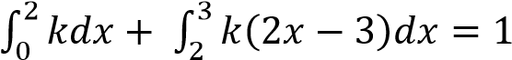
Solution

k =

When x = 0, f(x) = k =

When x = 2, f(x) = k =

When x = 3, f(x) =

(2
x3
-

3)

=

f(x)

0
2 3 x

f(x) =

⁄

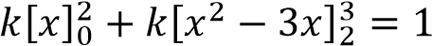
- P(X<1) =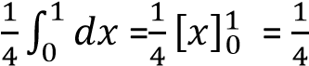
- P(X > 2.5) =

Revision exercise 2
(Answers are given in the square brackets, [ ], at end of each question)
- A random variable x of a continuous p.d.f is given by 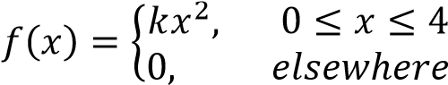
  - Sketch f(x)
  - Find (i) value of k (=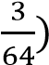(ii) E(X) = 3 and var (X) = 0.6 (iii) P(1<X<2) = 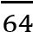
- A random variable x of a continuous p.d.f is given by 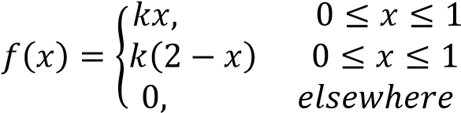
Find (i) constant k = 1 (ii) E(X) = 1 (iii) var(X) =(iv)P(0.75 < X < 1.5) = 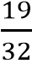(v) mode =1
- A random variable x of a continuous p.d.f is given by 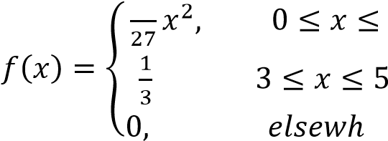
    - Sketch f(x)
    - Find (i) E(X) = 3417 (ii) standard deviation = 1.008
- A random variable x of a continuous p.d.f is given by 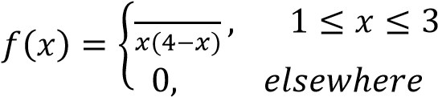
  - Show that k = 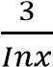
  - Find (i) E(X) = 2 (ii) Var(X) = 4-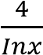
- A random variable x of a continuous p.d.f is given by 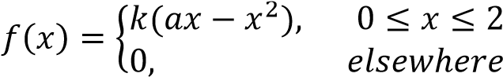
  - Show that k = 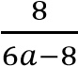
(ii) | Given that E(X) = 1, find the values of a (=2) and k(=0.75)
(iii) | For the above values of a and k, find Var(X) = 0.2
- A random variable x of a continuous p.d.f is given by 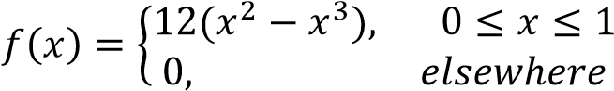
Find the (i) mean = 0.6 (ii) standard deviation = 0.2
- A random variable x of a continuous p.d.f is given by 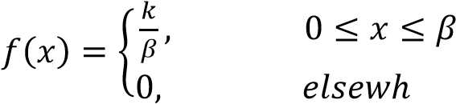
Find (i) value of k (=1) (ii) mean = (iii) standard deviation = 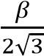
- A random variable x of a continuous p.d.f is given by 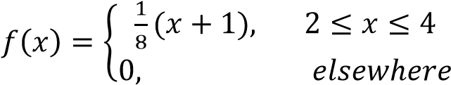
Find (i) mean = 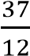(ii) var(X) 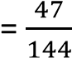(iii) P(2.5 < x< 3) = 0.234
- A random variable x of a continuous p.d.f is given by 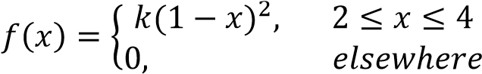
Find (i) constant k = 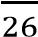 (ii) mean = (iii) standard deviation = 0.94
- A random variable x of a continuous p.d.f is given by 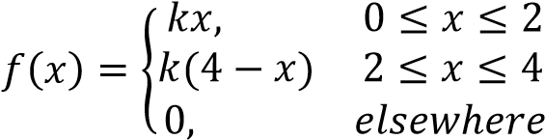
Find (i) value of k = (ii) E(X) = 2 (iii) Var(X) = (iv) P(X< 1) = (iv) P(X<X<3) =

